**Experiment no. 12**

**Name: Sonali Dattatray Kaingade**

**PRN: 21620002**

**Title:** Attribute for classification ,Write a program to find

A. Gain

B. Gini index

For categorical and numerical values.

**code:**

#include <bits/stdc++.h>

using namespace std;

vector<string>attributes;

map<string,int>class_attri_cnt;

map<string,unordered_set<string>>values_in_attributes;

map<string,int>attribute_cnt;

map<string,map<string,int>>attribute_yn_cnt;

double calculateGain(string attri_name, double entropy){

double info = 0.0;

unordered_set<string>sets = values_in_attributes[attri_name];

for(auto it : sets){

double total = class_attri_cnt["Yes"]+class_attri_cnt["No"];

double cnt_attri = attribute_cnt[it];

double cnt_attri_yes = attribute_yn_cnt[it]["Yes"];

double cnt_attri_no = attribute_yn_cnt[it]["No"];

if(cnt_attri_yes != 0){

info += cnt_attri/total*(-cnt_attri_yes/cnt_attri * log2(cnt_attri_yes/cnt_attri));

}

if(cnt_attri_no != 0){

info += cnt_attri/total*( -cnt_attri_no/cnt_attri * log2(cnt_attri_no/cnt_attri)) ;

}

}

double gain = entropy - info;

return gain;

}

double calculategini(string attri_name){

double gini = 0.0;

unordered_set<string>sets = values_in_attributes[attri_name];

//cout << sets.size() << endl;

for(auto it : sets){

double total = class_attri_cnt["Yes"]+class_attri_cnt["No"];

double cnt_attri = attribute_cnt[it];

double cnt_attri_yes = attribute_yn_cnt[it]["Yes"];

double cnt_attri_no = attribute_yn_cnt[it]["No"];

gini += cnt_attri/total * (1-(cnt_attri_yes/cnt_attri)*(cnt_attri_yes/cnt_attri)-(cnt_attri_no/cnt_attri)*(cnt_attri_no/cnt_attri));

}

return gini;

}

int main(){

ifstream input("info-gain.csv");

string line, day, outlook, temp, humidity, wind, playGame;

int j = 0;

while(getline(input,line)){

stringstream str(line);

getline(str,day,',');

getline(str,outlook,',');

getline(str,temp,',');

getline(str,humidity,',');

getline(str,wind,',');

getline(str,playGame,'.');

if(j == 0){

j++;

attributes.push_back(day);

attributes.push_back(outlook);

attributes.push_back(temp);

attributes.push_back(humidity);

attributes.push_back(wind);

attributes.push_back(playGame);

continue;

}

class_attri_cnt[playGame]++;

values_in_attributes["outlook"].insert(outlook);

values_in_attributes["temp"].insert(temp);

values_in_attributes["humidity"].insert(humidity);

values_in_attributes["wind"].insert(wind);

attribute_cnt[outlook]++;

attribute_cnt[temp]++;

attribute_cnt[humidity]++;

attribute_cnt[wind]++;

attribute_yn_cnt[outlook][playGame]++;

attribute_yn_cnt[temp][playGame]++;

attribute_yn_cnt[humidity][playGame]++;

attribute_yn_cnt[wind][playGame]++;

}

double yes_cnt = class_attri_cnt["Yes"];

double no_cnt = class_attri_cnt["No"];

double total = yes_cnt + no_cnt;

//cout << yes_cnt << no_cnt << total << endl;

double entropy_ca = (-yes_cnt/total * log2(yes_cnt/total)-no_cnt/total * log2(no_cnt/total));//entropy of class attribute

cout << "Entropy of class attribute is: " << entropy_ca << endl;

ofstream output("gain_output.csv");

output << "Attributes"<<"," << "Gain" << "," << "Gini"<< endl;

for(int i = 1; i<5; i++){

double gain = calculateGain(attributes[i],entropy_ca);

double gini = calculategini(attributes[i]);

output << attributes[i]<<"," << gain << "," << gini<< endl;

}

}

**Result:**

**Input.csv:**

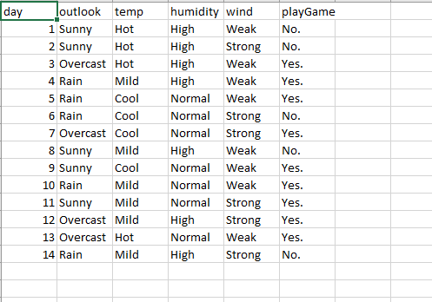

**Output.csv:**

